import cv2

import numpy as np

import matplotlib.pyplot as plt

from google.colab import files

from IPython.display import Image

uploaded = files.upload()

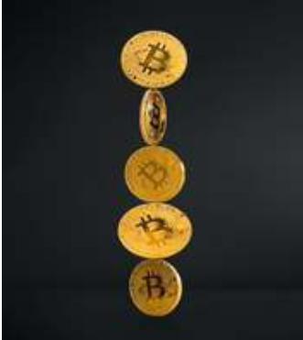

image = cv2.imread('s.jpg')

gray = cv2.cvtColor(image, cv2.COLOR_BGR2GRAY)

plt.imshow(gray, cmap='gray')

blur = cv2.GaussianBlur(gray, (11, 11), 0)

plt.imshow(blur, cmap='gray')

canny = cv2.Canny(blur, 30, 200, 3)

plt.imshow(canny, cmap='gray')

dilated = cv2.dilate(canny, (1, 1), iterations=0)

plt.imshow(dilated, cmap='gray')

(cnt, hierarchy) = cv2.findContours(

    dilated.copy(), cv2.RETR_EXTERNAL, cv2.CHAIN_APPROX_NONE)

rgb = cv2.cvtColor(image, cv2.COLOR_BGR2RGB)

cv2.drawContours(rgb, cnt, -1, (0, 255, 0), 2)

plt.imshow(rgb)

print("coins in the image : ", len(cnt))